School Name:

Indiana DON’T QUIT! ® Campaign
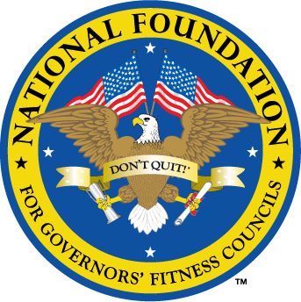
National Foundation for Governors’ Fitness Councils
Accepting Applications: 2/3/2020 – 3/20/2020

The National Foundation for Governors’ Fitness Councils (NFGFC) has partnered with Governor Eric Holcomb to bring the DON’T QUIT! Campaign to the State of Indiana this year. Our mission is to identify and support schools that prioritize student fitness, but lack adequate resources. We will gift a new fitness center to three schools in Indiana for showing dedication and leadership in promoting fitness. Each DON’T QUIT! Fitness Center is worth $100,000 and includes strength training equipment, cardio fitness equipment, and a circuit training system. This is a gift, not a grant. All you have to do is complete the application below to nominate your school to win a fitness center. Take a chance! It’s as easy as 1, 2, 3.

STEP 1: Make sure you qualify.
- The school must be a public or public charter school.
- The majority of students must be between the ages of 8-14 years old.
- The school must have a room on the school’s property that is available and ready for equipment installation during the summer of 2020.
- The room must be approximately 900-2000 square feet.

STEP 2: Fill out your school’s profile.
School name:
Address:
City, state, zip:
Grade levels:
Student enrollment:
Number of students eligible for free or reduced lunch:
Number of physical education teachers:

Your name:
Affiliation / title:
Work phone:
Cell phone:
Email address:
Number of years you’ve worked at this school:

Principal’s name:
Work phone:
Cell phone:
Email address:
Number of years they’ve worked at this school:

Current Equipment –
Does your school currently have a fitness center or fitness equipment?
How many pieces of equipment?
What type of equipment?
What condition is it in?
Insert 3-4 photos (.jpg format) of your school’s current equipment:

Designated Room for Fitness Center –
Square footage / length x width:
What floor (basement, first/ground floor, second floor) is the room on?
Height of ceiling:
Width of doors:
Earliest installation date:
Insert 3-4 photos (.jpg format) of the room from all angles:

STEP 3: Tell us why.
- Why does your school deserve the fitness center award?
- What challenges does the school face and what is it doing to overcome them?
- What have you done (or currently do) to prioritize student fitness?
- What would you do with a new fitness center?

Please limit your essay to 500 words total. Be as specific as possible! Bulleted lists are acceptable.

We highly encourage you to submit a video as well. Show us your personality! Get your students and staff involved. Be creative and have fun! Videos can be filmed with a smart phone. Please keep the video under 3 minutes. Download the video to YouTube and provide the link below.

Video:

DEADLINE: Friday, March 20, 2020 at 11:59 pm PT
This award is contingent upon a successful site visit, so be sure to provide honest answers. Save your application as a Word document (.doc/.docx) and email it to kelly@natgovfit.org by the deadline date. For more information, please visit our website at www.natgovfit.org/nominate-your-school.

Join the #dontquit campaign! Like us on Facebook @natgovfit, follow us on Instagram and Twitter @natgovfit, and tag someone to nominate your school!

